Dynamically Refresh
Spring Cloud Bus

Issue: when we update the confirm server then the client does not update we need to restart the client by ourselves.

- Request end point to see the config server from url

>> http://localhost:8888/configdemo/dev

- Configdemo: is the client server name
- Dev : is what we want to retrieve
- 8888: is the server port configuration server
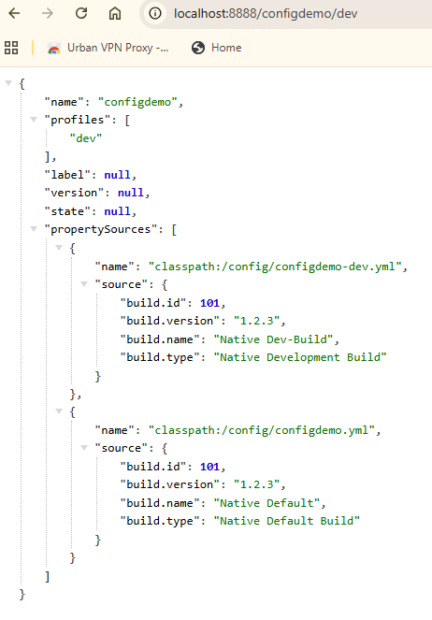
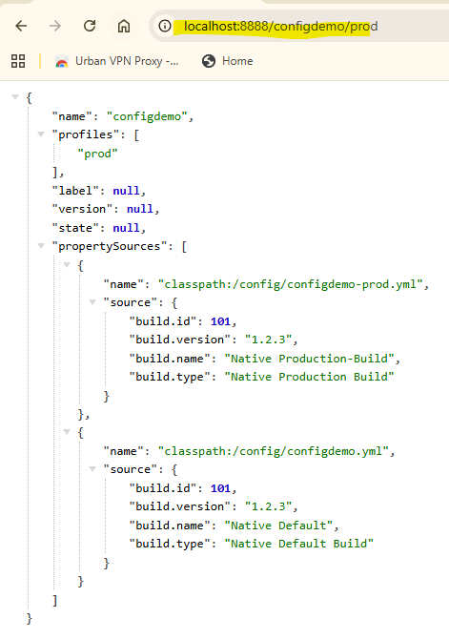

To resolve the issue, we can do it manually: with the actuator

- Client

Add dependencies:
<dependency>
<groupId>org.springframework.boot</groupId>
<artifactId>spring-boot-starter-actuator</artifactId>
</dependency>

URL to refresh: http://localhost:8080/actuator/refresh
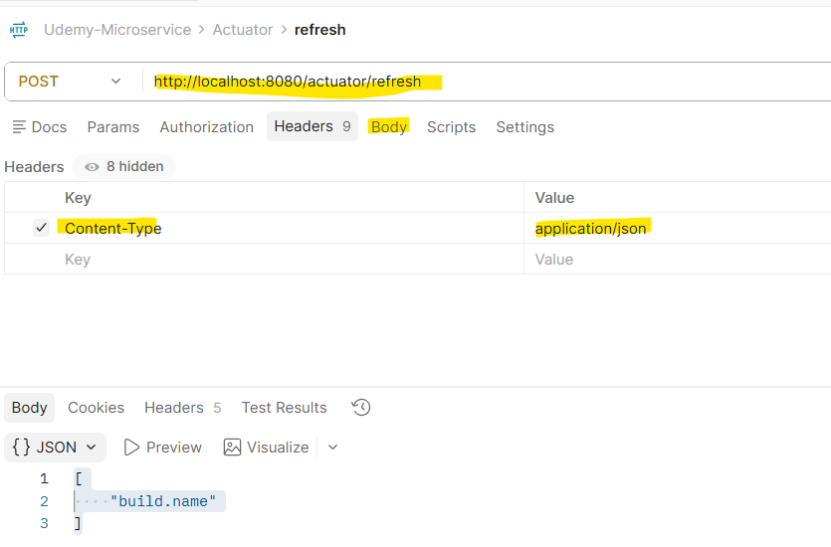

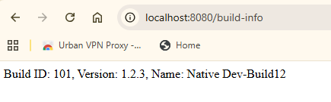

យើងធ្វើចឹងបានតែមួយទេ ចុះបើយើងមាន Microservice ច្រើនយើងហើយអាចជា Hard work ចឹងហើយបានយើង ត្រូវប្រើប្រាស់ Spring Cloud Bus មកជួយវិញ ដោយធ្វើការ Brocase and subscriber.

Spring Cloud Bus

- Need message broker Rabbit MQ
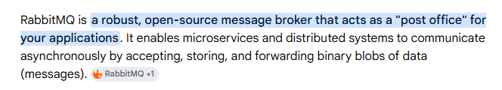

- Run RabbitMQ with docker :

# latest RabbitMQ 4.x
docker run -it --rm --name rabbitmq -p 5672:5672 -p 15672:15672 rabbitmq:4-management

Step by step setup

- Client
- Add dependencies: actuator, spring cloud bus

<dependency>
<groupId>org.springframework.boot</groupId>
<artifactId>spring-boot-starter-actuator</artifactId>
</dependency>

<!-- connect to rabbit mq -->
<dependency>
<groupId>org.springframework.cloud</groupId>
<artifactId>spring-cloud-starter-bus-amqp</artifactId>
</dependency>

- Application.yml

spring:
application:
name: configdemo
profiles:
active: dev
config:
import: optional:configserver:http://localhost:8888

management:
endpoints:
web:
exposure:
include: refresh, health # Adds 'refresh' to the allowed endpoints

build:
id: ${ID}
version: ${VERSION}
name: ${NAME}

+ ចំណាំ កន្លែង ភ្ជាប់ទៅ actuator
management:
endpoints:
web:
exposure:
include: refresh, health # Adds 'refresh' to the allowed endpoints

+ ចំណាំ កន្លែង ភ្ជាប់ទៅ
profiles:
active: dev
config:
import: optional:configserver:http://localhost:8888

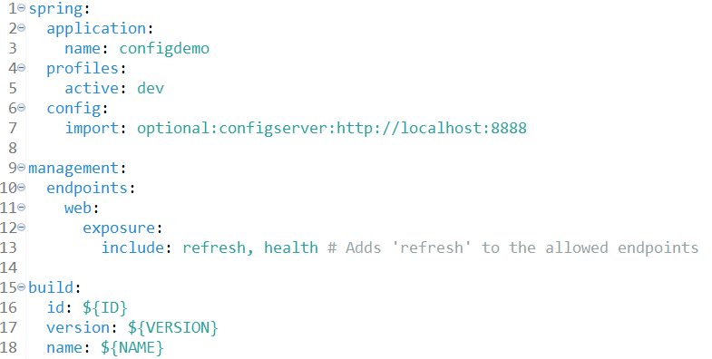

- Config server: actuator, spring cloud bus

<dependency>
<groupId>org.springframework.cloud</groupId>
<artifactId>spring-cloud-starter-bus-amqp</artifactId>
</dependency>

<!-- connect to rabbit mq -->
<dependency>
<groupId>org.springframework.cloud</groupId>
<artifactId>spring-cloud-starter-bus-amqp</artifactId>
</dependency>

- configdemo-dev.yml

build:
id: 101
version: 1.2.3
name: "Native Dev-Vibol"
type: "Native Development Build"

spring:
rabbitmq:
host: localhost
port: 5672
username: guest
password: guest

management:
endpoints:
web:
exposure:
include: "*"

- Tesing

- url from the client : http://localhost:8080/build-info
- url for server end point : http://localhost:8888/configdemo/dev

- when we can from the server config-dev: after we can use the Post request to update the configuration from the server.

- http://localhost:8080/actuator/busrefresh

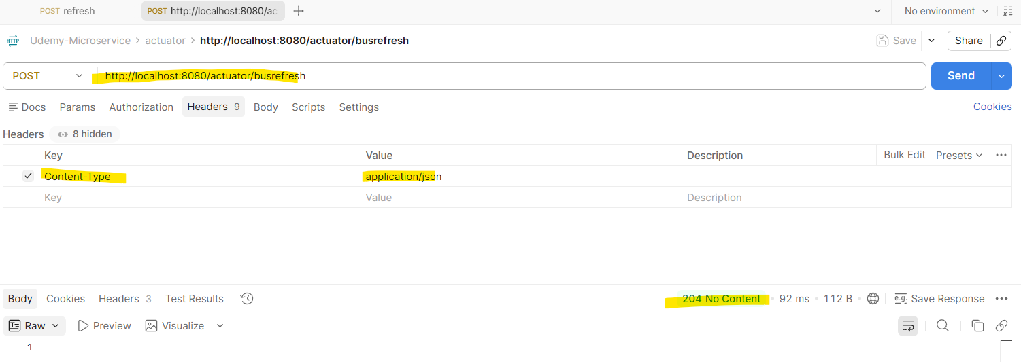

- Rabbit MQ is the message broker

